Back to the office by June 22, 2020 (hopefully…)
In accordance with the guidelines as set forth by Governor Wolf, Kitay Law Offices will begin to slowly operate from our locations in Allentown, Wyomissing and Kennett Square.
We are all in Yellow Phase now.

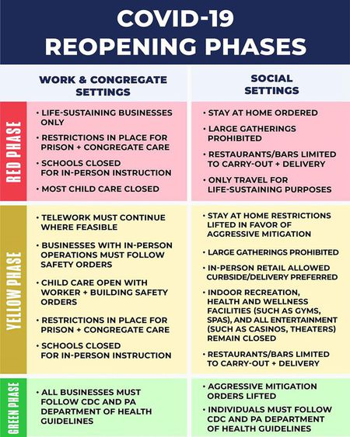

Zoom calls and telework from home continue where feasible
It is important to note that Zoom calls and telework from home must continue where feasible. We will have to take this day-by-day. Your patience during this time is appreciated.

Kitay Law Offices Staff Safety is the #1 Priority

According to the Secretary of the Commonwealth of Pennsylvania Department of Health, the following guidelines must be adhered to:
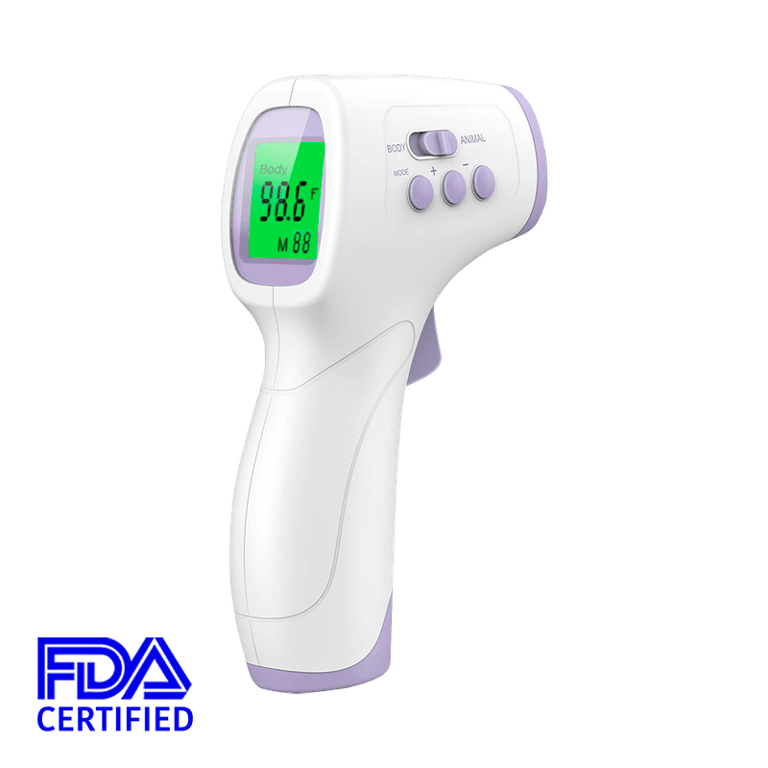
- TEMPERATURE TAKING - Each office is equipped with infrared thermometers for the implementation of temperature screening before an employee enters the office. Anyone with an elevated temperature or fever of 100 degrees Fahrenheit or higher will be sent home and denied access to the building.

- MASKS TO BE PROVIDED – Kitay Law Offices will provide masks for employees to wear during their time at the business, and it is a mandatory requirement to wear masks while on the work site, except you do not need to wear mask while in your own workspace and away from others, and to the extent an employee is using break time to eat or drink, in accordance with the guidance from the Department of Health and the CDC. Kitay Law Offices may approve masks obtained or made by employees in accordance with Department of Health guidance.

- STAY HOME WHEN YOU’RE SICK - Employees who have symptoms (i.e., fever, cough, or shortness of breath) should notify their supervisor, stay home and follow CDC-recommended steps.

- GETTING SICK WHILE AT WORK - If the employee becomes sick during the workday, the person should notify their supervisor and be sent home immediately. To the extent possible, the employee, supervisor or other appropriate staff at Kitay Law Offices should ensure that:
  - Surfaces in the employee’s workspace be cleaned and disinfected.
  - Other employees who had contact with the ill employee 48 hours prior to when symptoms first began, be told that they have been exposed to Covid-19 and that they need to monitor their own symptoms.
  - As others at the workplace with close contact within 6 feet of the employee during this time would be considered exposed, they will make every effort to monitor their own symptoms.
  - All exposed employees should be tested. You are encouraged to be first be screened by your physician and get a prescription for testing prior to visiting a testing location.

Suggested Location In Allentown:
COVID-19 testing center
Lehigh Valley Hospital–17th Street
1627 W Chew St, Allentown, PA 18102
(610) 402-8000

- Appointment required
- Referral required
- Tests limited to certain patients
- Drive-through
- Verify testing center is open info before going

Suggested Location in Reading:
Covid-19 Testing Center – Urgent Care Site
Tower Health
1212 Liggett Avenue, Reading, PA, 19611
(484) 628-8000
- Patients who have a prescription from their physician will bypass the initial assessment at the urgent care site.
- Patients may also come to the urgent care sites without a prescription from their doctor but will be subject to the required assessment by the urgent care staff to determine if testing is appropriate.

- KEEPING YOUR DISTANCE – Kitay Law Offices and all employees shall provide sufficient amount of space for employees to have breaks and meals while maintaining a social distance of 6 feet, and while arranging seating to have employees facing forward—not across from each other—in eating and break settings. Everyone has their own office, so let us keep to our own spaces when eating if at all possible. When possible, eating must occur at your workstation (or outside if on break).

- FOR MEETINGS – Kitay Law Offices and all employees shall make every effort to conduct meetings and trainings virtually (i.e., by phone or through the internet). If a meeting must be held in person, limit the meeting to the fewest number of employees possible, not to exceed 10 employees at one time, and maintain a social distance of 6 feet.

- CLEANING YOUR HANDS AND WORK SPACES FREQUENTLY- Kitay Law Offices will provide employees access to regular handwashing with soap, hand sanitizer, and disinfectant wipes and will ensure that common areas (including but not limited to break rooms, dining facilities, rest rooms, conference rooms) are cleaned on a regular basis, including midway during the day

  - DAILY CLEANING – (1) Each staff member is responsible for properly cleaning his or her own workstation each day; (2) The staff, together, shall make schedule of rotating responsibility to clean, wipe down and/or spray frequently-used common areas; (3) Wiping and spraying of common areas must occur twice per day (mid-day and end of day); (4) The staff shall create a schedule and check-off sheet for each office.

- NO FAMILY AND FRIENDS PERMITTED – Kitay Law Offices prohibits non-essential visitors from entering the premises of the business; this means that a client’s family/friends and your family/friends—including your children—are not permitted in the office until further notice.

- IF SOMEONE GETS SICK AND POSSIBLY EXPOSED TO COVID-19 – Kitay Law Offices has established these protocols for execution upon discovery that the firm has been exposed to a person who is a probable or confirmed case of COVID-19:

  - The office will be closed immediately, if there is a probable or confirmed
case of COVID-19.
- Open outside doors and windows and use ventilation fans to increase air circulation in the area.
  - Wait a minimum of 24 hours, or as long as practical, before beginning
cleaning and disinfection.
  - Cleaning staff should clean and disinfect all areas such as offices, bathrooms, common areas including but not limited to employee break rooms, conference rooms and kitchen, shared electronic equipment like keyboards, remote controls.
  - Identify employees that were in close contact (within about 6 feet
for about 10 minutes) with a person with a probable or confirmed
case of COVID-19 from the period 48 hours before symptom onset
to the time at which the patient isolated.

Client Protocols for Covid-19

- APPOINTMENTS ONLY - Clients will be admitted to the office by appointment only. Each client will have his or her temperature taken, will be asked the Covid-19 screening questions and must always maintain a social distance of 6 feet. All clients are required to wear masks while on premises or they will not be allowed in the office. All visitors shall be notified in advance that only the client or potential client will be allowed into the office. No other visitors/friends/family members shall be admitted.

- SIGNAGE - Signage in both Spanish and English will be posted at the main entrance of each office which will direct clients to call the office phone number when they arrive to the building for admittance. Screening questioning shall be conducted by phone. If all screening questions are satisfied, then the client will be subject to a temperature check at threshold to the building. If the temperature check is satisfied, only then will admittance be allowed.

- ALLENTOWN OFFICE - Allentown office clients will enter the building from the parking lot side entrance, after Diego has: (1) taken their temperature, (2) asked the Covid-19 screening questions and (3) confirmed that they are wearing a mask.* Diego will escort the client directly to the conference room. Allentown clients are only permitted in this space and shall not be allowed to any other part of the buildings. The restroom near the conference room will be used for clients only.

- WYOMISSING OFFICE - Wyomissing office clients will enter the building from the front entrance, after Erika has: (1) taken their temperature, (2) asked the Covid-19 screening questions and (3) confirmed that they are wearing a mask.* Erika will escort the client directly to the small conference room. Wyomissing clients are only permitted in this space and shall not be allowed to any other part of the building. The current Women’s bathroom, which is the one closest to the large conference room, will be clients-only. All staff will only use the current Men’s bathroom, regardless of gender.

* It shall not be the responsibility of any Kitay Law Offices staff to provide masks to clients.

- COVID-19 SCREENING QUESTIONS (will be provided in both Spanish and English):

  - Have you tested positive for COVID-19?
  - Have you been exposed to anybody who has tested positive for COVID-19?
  - Have you been on a cruise or traveled outside the country in the last 30 days?
  - Have you been exposed to anybody from New York or Northern New Jersey in the past 2 weeks?
  - “Have you felt like you had a fever in the past day?”
  - “Do you have a new or worsening cough today?”
  - “Do you have any of these other symptoms?
    - Shortness of breath or difficulty breathing
    - Fatigue
    - Muscle or body aches
    - Headache
    - New loss of taste or smell
    - Experience chills, repeated shaking with chills
  - If the client fails any of the screening questions, DO NOT ALLOW THEM ACCESS INTO THE OFFICE
  - Let the client know: Please go to the doctor immediately.

- NEED TO TRACK MEETINGS SO THAT CLIENTS ARE NOT ENTERING THE BUILDING AT THE SAME TIME – The staff at each office shall be individually responsible for creating their own schedule for conference room meeting times. Everyone must use conference rooms as designated in the Needles calendar when scheduling in-person appointments to avoid double-booking. Ensure there is a sufficient gap between meeting times so the building does not become crowded.

- HIGH RISK CLIENTS - Special arrangements will be made for high-risk and elderly persons to attend meetings during off hours on a case-by-case basis.

- PLEASE KEEP YOUR WORKPLACE CLEAN AND PUT IN EXTRA EFFORT TO KEEP ALL BATHROOMS AND KITCHENS CLEAN

  - Each personal office space, as well as common areas like the kitchen and conference rooms will be equipped with cleaning and disinfecting products to clean surfaces and shared electronics, ie: Clorox wipes, hand sanitizer.
  - Each staff member will be provided with a mask. You can also bring your own.
  - Wash your hands thoroughly and frequently.
  - Clean and disinfect high-touch areas daily. See rotation schedule regarding wiping down high-frequency touch surfaces daily. This includes doorknobs, desks, filing cabinets copiers and printers in common areas.
COVID-19: Symptoms
Symptoms of the coronavirus can be similar to other seasonal respiratory infections like colds and influenza (“the flu"). Most commonly these include fever, muscle aches, cough, and difficulty breathing. In addition, you may experience chills, repeated shaking with chills, muscle pain, headache, sore throat and new loss of taste or smell.
Many patients have COVID-19 infection with no symptoms at all (asymptomatic infection). Most patients with COVID-19 have only mild flu-like and respiratory symptoms, which can be managed at home. However, some patients may develop severe pneumonia and breathing problems that require hospitalization.
COVID-19 affects different people in different ways. Infected people have had a wide range of symptoms reported – from mild symptoms to severe illness.
Look for emergency warning signs for COVID-19. If someone is showing any of these signs, seek emergency medical care immediately:
Trouble breathing
Persistent pain or pressure in the chest
New confusion
Inability to wake or stay awake
Bluish lips or face
Call your medical provider for any other symptoms that are severe or concerning to you.
If you have respiratory or flu symptoms, please call your doctor’s office ahead of time.
For very severe symptoms like trouble breathing, call 911 or go to a hospital emergency room.

